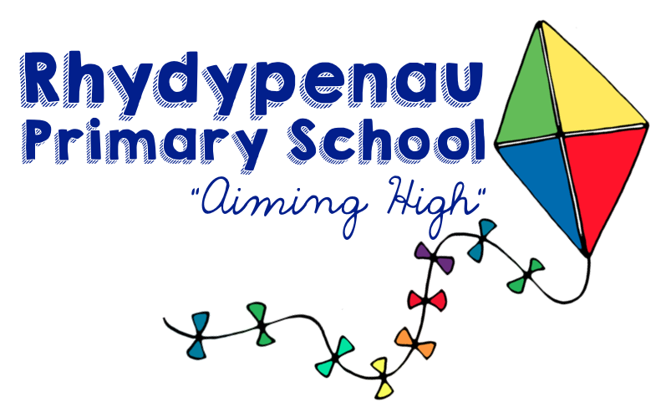



Charging & Remissions Policy

DEVELOPMENT, MONITORING & REVIEW OF THIS POLICY
This ‘Charging & Remissions Policy’ will be reviewed regularly, and adapted in line with Local Authority Guidance.
SCHEDULE FOR DEVELOPMENT, MONITORING & REVIEW
This policy was agreed by teachers:
This policy was agreed and adopted by the Governing Body: | Dec 15
The implementation of this policy will be reviewed by: | The Governing Body
This policy will be reviewed: | Annually
This policy was last reviewed: | Autumn Term 2024
This policy is due to be reviewed: | Autumn Term 2025
Chair of Governors’ Signature:
Headteacher’s Signature:

SCOPE OF THE POLICY
All staff and governors are committed to ensuring equality of opportunity and fairness in all areas of school life and to valuing the diversity of our colleagues, pupils and people living within our local communities.
It is this commitment which lies at the heart of our aim of providing an environment that is committed to including and encouraging all pupils, parent and colleagues to reach their full potential regardless of disability, race, gender, age, religion or belief, sexual orientation and gender reassignment, social or educational background or family/care responsibilities.
We are also determined to create a school environment which supports our vision and values and which is free from any form of discrimination, harassment or bullying and within which all individuals are treated with respect, fairness and courtesy.
PURPOSE OF THE POLICY
The purpose of this policy is to set out what charges can and cannot be made for activities in Rhydypenau Primary School. The policy has been drawn up in accordance with Sections 449-462 of The Education Act 1996 which sets out the law regarding what charges can and cannot be made for activities in schools maintained by local authorities.
THE PUPIL DEPRIVATION GRANT (PDG)
To provide equality of opportunity and to ensure that no child is impacted as a result of financial barriers, for the academic year 2024-25, pupils in receipt of free school meals will not be charged for one payable club for one term (Y3-6), for educational visits or for residential visits. This will be reviewed in the light of subsequent changes to the PDG.

CIRCUMSTANCES WHERE NO CHARGE IS MADE
No charge will be made for:
1) Education provided wholly or mainly during school hours:
⇒ Activities which are part of the National Curriculum, or are part of a prescribed examination syllabus, or part of Religious Education.
⇒ The supply of any materials, books and instruments or other equipment.
2) Transport
⇒ Transporting registered pupils to or from the school premises, where the local authority has a statutory obligation to provide transport.
⇒ Transporting registered pupils to other premises where the Governing Body or Local Authority has arranged for pupils to be educated.
⇒ Transport provided in connection with an educational visit which is part of the National Curriculum.
3) Residential Visits
⇒ Education provided on any visit that takes place during school hours.
⇒ Education provided on any visit that takes place outside school hours if it is part of the National Curriculum, or part of religious education.
⇒ Supply teachers to cover for those teachers who are absent from school;
⇒ Accompanying pupils on a residential visit.

CIRCUMSTANCES WHERE THE SCHOOL MAY CHARGE PARENTS
Optional Extras
Charges may be made for other activities known as ‘optional extras’. Where an optional extra is being provided, a charge may be made for providing materials, books, instruments, or equipment as follows:-
1. Education
⇒ Activities which take place mainly or wholly out of school time if they are not part of the National Curriculum and not part of religious education.
⇒ Materials used in practical subjects and project assignments provided parents have agreed in advance that they or the pupil wish to keep the finished product e.g. ingredients or materials.
2. Music Tuition
⇒ Musical instrument tuition provided to individual pupils or to a small group of pupils if the teaching of music tuition is not part of the National Curriculum or a public examination syllabus being followed by the pupil.
3. Transport
⇒ Transport that is not required to take the pupil to school or to other premises where the governing body has arranged for the pupil to be provided with education.
4. Board and Lodgings
⇒ The cost of boarding and lodging for residential trips, even when taking place largely during school time.
VOLUNTARY CONTRIBUTIONS
Although schools cannot levy a charge for school time activities, voluntary contributions will often be sought from parents for activities which supplement the normal school curriculum.
Requests to parents for voluntary contributions will state that:-
⇒ there is no legal obligation to make a voluntary contribution;
⇒ pupils will not be excluded through parents’ inability or unwillingness to pay;
⇒ pupils of parents who cannot contribute will not be treated any differently;
⇒ where there are not enough voluntary contributions to make the activity possible and there is no way to make up the shortfall, the activity will be cancelled.
RPS-Policy/Charging & Remissions/Owner/December 2015
Requests made for voluntary contributions made in respect of individual pupils will include any element of subsidy for any other pupils wishing to participate in the activity whose parents are unwilling or unable to pay the full charge.
REMISSIONS
Governors have agreed that parents who demonstrate that they are in receipt of the following benefits will be exempt from paying the cost of board and lodging of a residential trip:-
⇒ Income Support.
⇒ Income Based Jobseeker's Allowance.
⇒ In receipt of any other benefit or allowance, or entitled to any tax credit under the Tax Credits Act 2002 or element of such a tax credit, as may be prescribed by regulations from time to time for any period wholly or partly comprised in the time spent on the trip.
The governing body may wish to remit in full or in part, the cost of other activities for parents in certain circumstances.
SUPPLEMENTARY INFORMATION
Uniform, P.E. Kit, Calculators, Pens etc. Aprons
Parents will be invited to equip their child with items of personal equipment intended to be used solely by their child.
Breakages and Damage
Where a student’s behaviour results in damage to school property or equipment, parents may be asked to pay for the necessary repair or replacement. Each incident will be dealt with at the schools discretion.
CHARGING FOR USE OF THE SCHOOL PREMISES
The school budget cannot be used to subsidise non-school activities. Community use of the school will at least cover the cost of letting the school to community groups. The charges set by the school cover the cost of opening the school, including the cost of caretaker time, cleaning and energy.

RPS-Policy/Charging & Remissions/Owner/December 2015

